Project Status Report

**Team Members:**

Ana Hou

Taruna Suryawanshi

Samantha Erickson

So far in our faux portfolio we have implemented the HTML components to all five of our web pages. We have included screenshots of our HTML code, as well as some screenshots of our webpages deployed onto a browser.

**Screenshot of Cover Page**

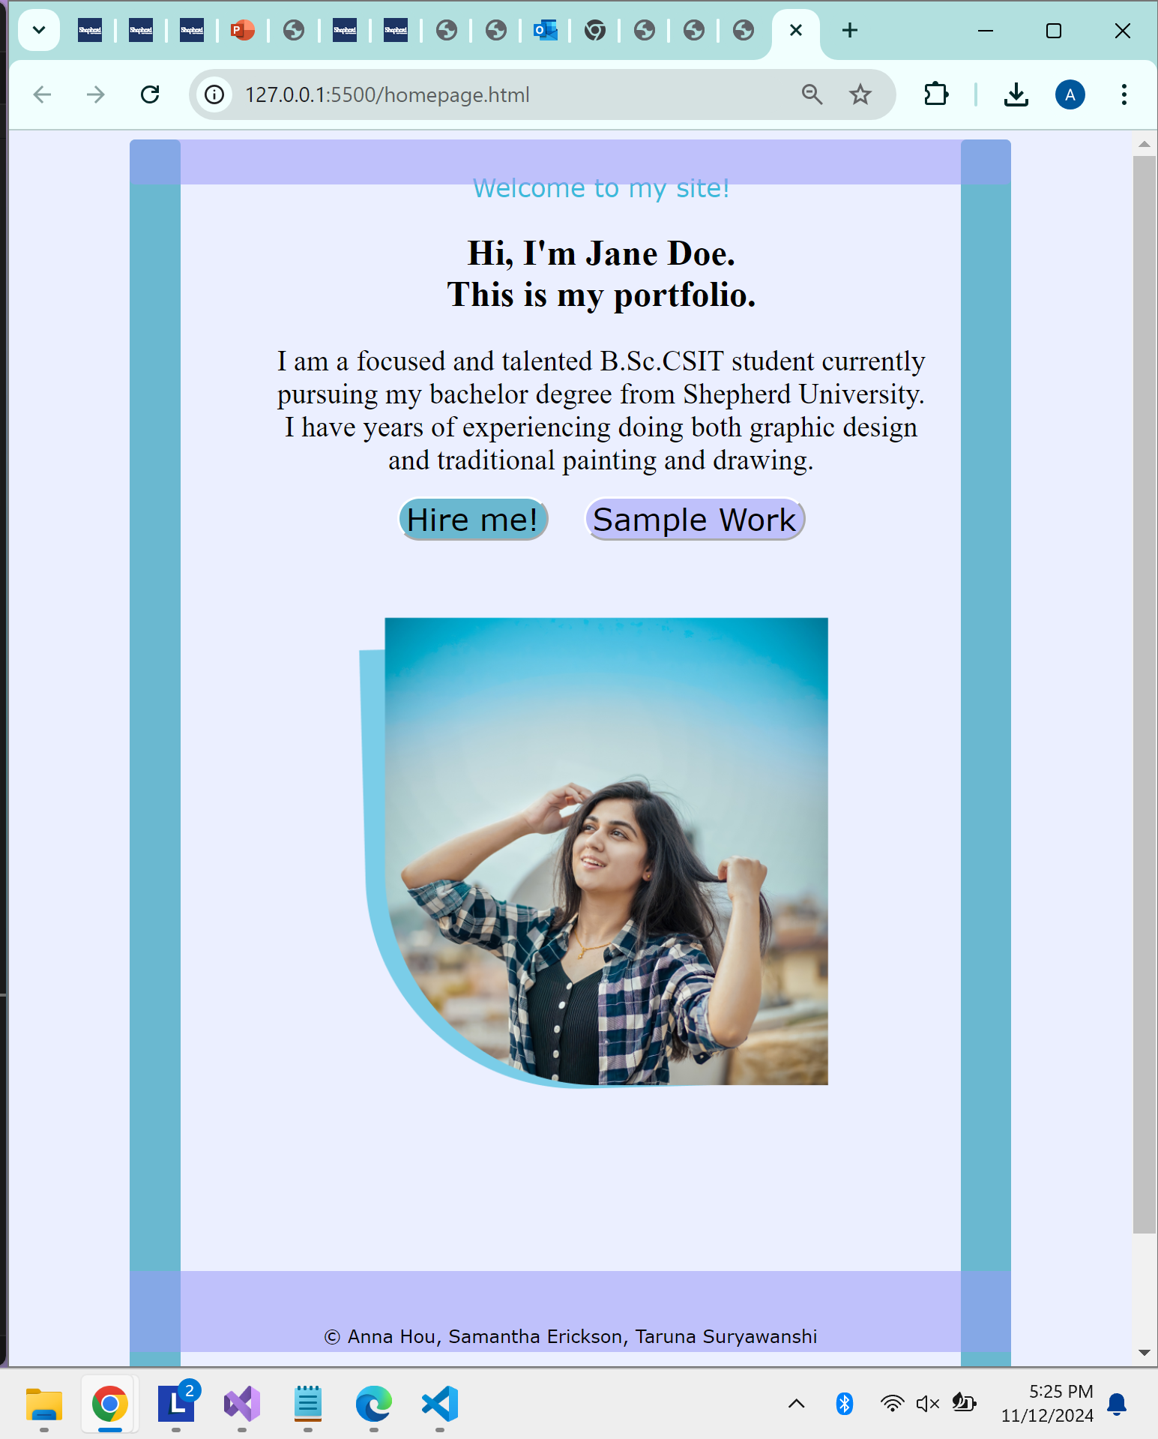

**Screenshot of the HTML and CSS for the Resume web page**

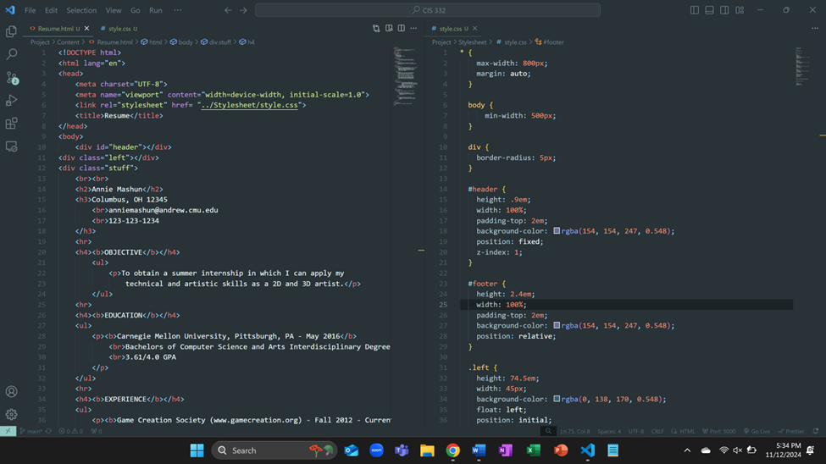**Screenshot of the Resume web page**

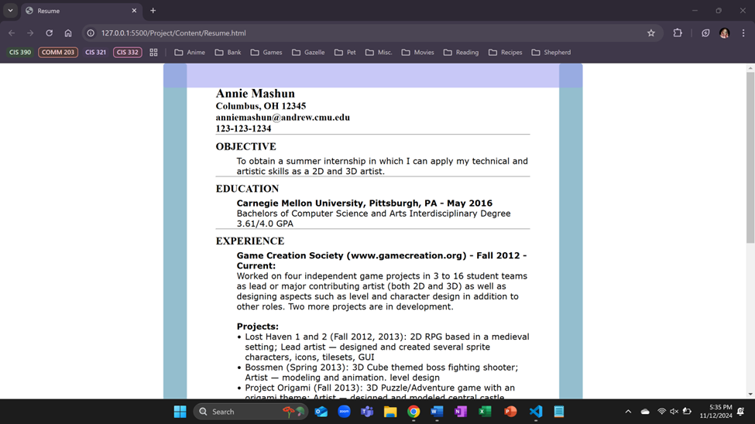

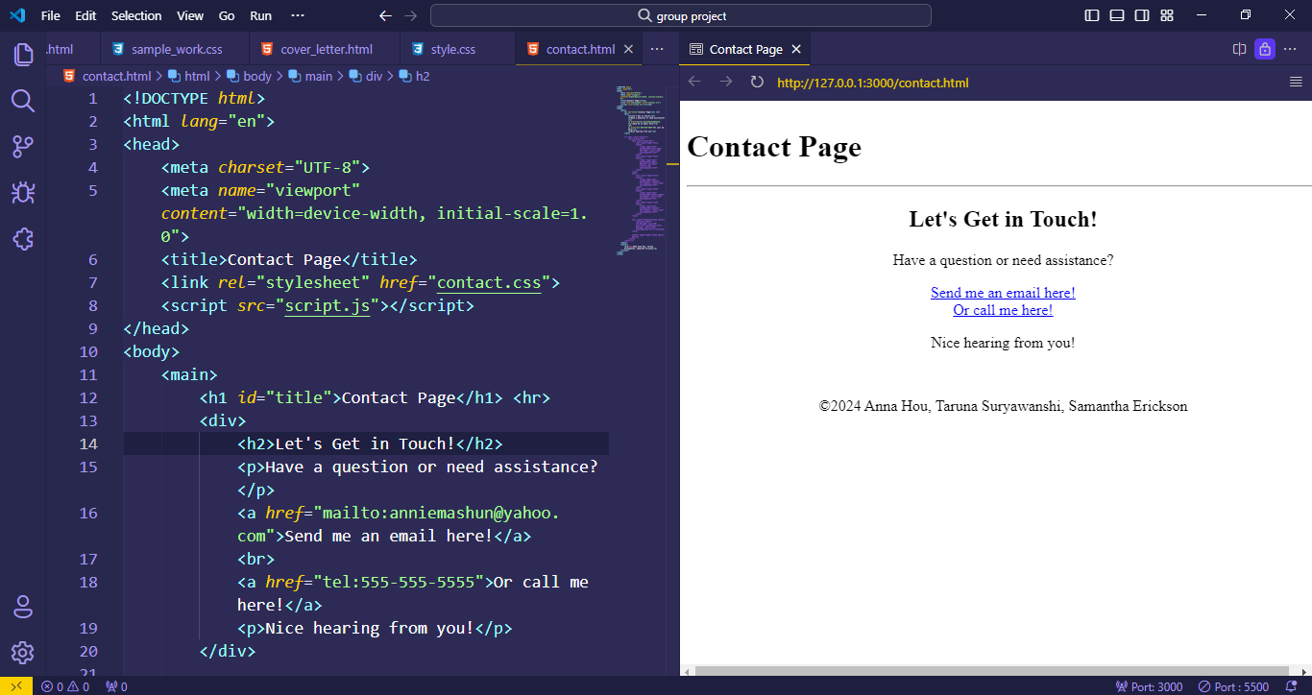

**Screenshot of Contact Page HTML and Live Preview**

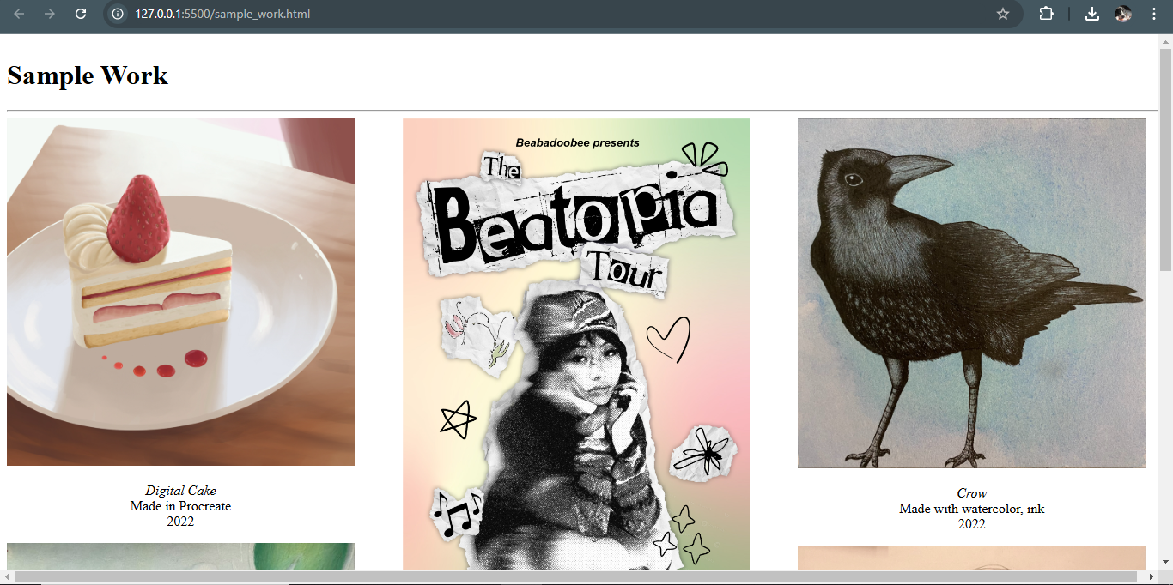

**Screenshot of Sample Work page**

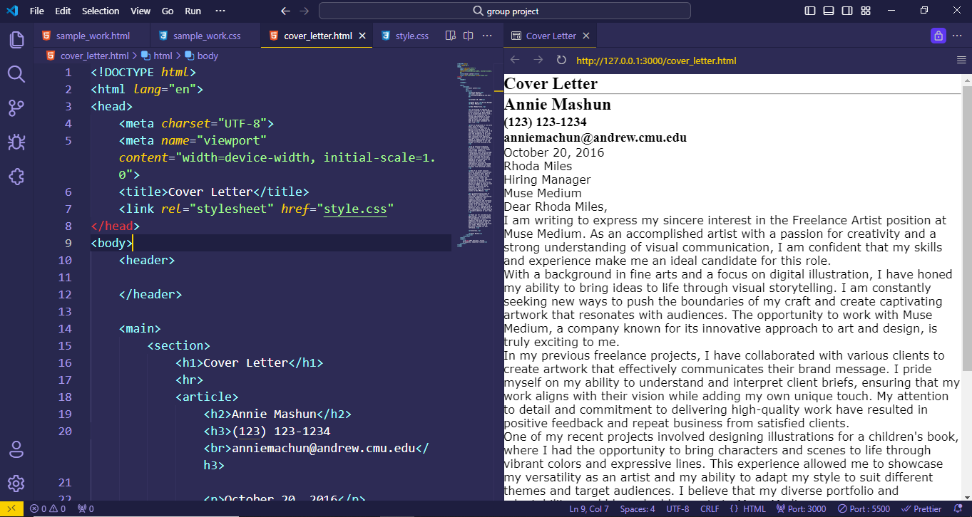

**Screenshot of Cover Letter HTML and Live Preview**

We currently have three goals we are focusing on. Our first goal is to figure out the JavaScript for our Contact Page. We aim to create a contact form that will send an email to our portfolio owner’s email. Currently, we have an email and phone link on our contact page as a placeholder for this.

Our second goal is to implement a functional navigation bar at the right side of the header of all the web pages. All five web pages will be listed, and whichever one is currently in use will be highlighted to be clear which web page the user is currently on.

Our third goal is to finish implementing more CSS to incorporate all the design choices we have planned. We will be working with a color palette to ensure we create an aesthetically unified website. All the footers and headers for all five web pages will be identical for consistency.